

American International University-Bangladesh (AIUB)  
**Department of Computer Science  
Faculty of Science & Technology (FST)**

**Emergency Helpline Management System**

A Software Requirement Engineering Project Submitted

By

|  |  |  |  |
| --- | --- | --- | --- |
| **Semester: Spring_22_23** | | **Section: I** | **Group Number: 7** |
| SN | Student Name | Student ID | Individual Marks |
| 1 | Shaif Ahamed Tamim | 20-43230-1 |  |
| 2 | Md. Mahmudur Rahman Badhon | 20-43213-1 |  |
| 3. | Gazi MD. Jubayar Hossain | 19-40016-1 |  |

The project will be Evaluated for the following Course Outcomes

|  |  |  |
| --- | --- | --- |
| Evaluation Criteria | Total Marks (50) | |
|  | |
| Introduction, Format, Submission, Defense | [10 Marks] |  |
| System Overall Description & Functional Requirements | [10 Marks] |  |
| System Quality Attributes and Project Requirements | [10 Marks] |  |
| UML and E-R Diagram with Data Dictionary | [10 Marks] |  |
| UI/UX Prototyping | [10 Marks] |  |

Software Requirements Specification

for

<Emergency Helpline Management System>

Version 1.3 approved

Prepared by <Group 7>

<American International University-Bangladesh>

<16.05.2023>

Table of Contents

Revision History 4

1. Introduction 5

1.1 Purpose 5

1.2 Document Conventions 6

1.3 Intended Audience and Reading Suggestions 6

1.4 References 8

2. Overall Description 9

2.1 Product Perspective 9

2.2 Product Functions 10

2.3 User Classes and Characteristics 12

2.4 Operating Environment 14

2.5 Design and Implementation Constraints 14

2.6 User Documentation 14

3. System Requirements 15

3.1 Functional Requirements (System Features) 15

3.2 Non-Functional/Quality Requirements 18

3.3 Project Requirements 21

4. Design and Interface Requirements 22

4.1 UML Diagrams 22

4.2 Data Dictionary 23

4.3 UI/UX Design Specification 24

5. Conclusion 33

# Revision History

|  |  |  |  |
| --- | --- | --- | --- |
| **Name** | **Date** | **Reason for Changes** | **Version** |
| Shaif | 18.04.2023 | Adding Medicine Dispensary | 1.1 |
| Badhon | 22.04.2023 | Adding payment method | 1.2 |
| Jubayar | 26.04.2023 | Adding Service Status | 1.3 |

# Introduction

## Purpose

The purpose of this SRS document is to describe all the requirements for the “Emergency Helpline Management System” software [1]. The following are some of the main stakeholders:

1. Civilian

2. Control room

3. Police

4. Ambulance

5. Fire service

6. Medicine dispensary shop

7. Developers and so on.

The user and government or private service providers use this document as the primary means to communicate confirmed requirements to the development team. The development team expects many face-to-face conversations that will undoubtedly be about requirements and ideas for requirements. However, only the requirements that appear in this version- 1.3, or a future revision, will be used to define the scope of the system.

In our daily life, we face many unexpected issues. We can solve some of the problems by ourselves, but there are many problems we cannot solve alone. For this, the need for emergency services can arise at any time, and it is crucial to get effective help on time. These help providers can be government or non-government organizations. This software will bring all emergency services into one platform. The government provides some of them for free and some of them are paid. This SRS document describes all the relevant people’s roles on this software. For example, civilians will request different kinds of services to the control room. The control room will forward the request to the relevant department or organization, such as a police station, medicine dispensary shop.

In Bangladesh, the government has launched emergency helpline numbers to provide emergency services such as medical assistance, rescue services, and crime-related services. So that general people can have emergency help easily. But in many situations, we cannot make calls from everywhere. Many people cannot decide what to do in emergency situations. And because of this, problems get worse. To address this problem, the government wants to launch this software which is available as an APP and a web-based system to complement the existing emergency helpline numbers. This system will allow people to request emergency services from anywhere and anytime using their internet-enabled devices. With the widespread availability of data connections and smartphones, this system will provide a more accessible and convenient way to seek help during an emergency. One of the benefits of this web-based system is its ability to track the victim’s location accurately. Unlike phone calls, which can be challenging to trace, the system can pinpoint the user’s location through their device's GPS. This feature enables emergency services to reach the victim quickly, which is crucial when time is short. To solve this crisis moment, we are developing this software. As we are in the age of advanced technology, almost everyone has a data connection in their device. So, people can access this system from anywhere and anytime.

## Document Conventions

**Acronyms:**

SRS- Software Requirement Specification

NID card- National Identity card

DOB- Date of Birth

1…* - one to many.

OS- Operating System.

IOS- iPhone Operating System.

PC- Personal Computer.

Mac- Macintosh.

## Intended Audience and Reading Suggestions

The document is intended for a wide range of readers with various project-related tasks and responsibilities. The document is meant for the following various reader types:

1. Developers: Developers are software engineers and programmers who are in charge of planning, developing, and executing the project. They want precise technical knowledge and specs in order to comprehend how to integrate and expand the system into their development environment. The SRS provides a detailed description of the software system to be developed, including its functional and non-functional requirements. This information is essential for developers to understand what the system is supposed to do and how it should perform.

2. Project Managers: Project managers are in charge of managing the whole project and guaranteeing its effective completion. They need a high-level grasp of the system's capabilities, features, and possible influence on the timing and resources of the project. The SRS helps project managers to plan and manage the development of the software system. It provides information on the system's scope, schedule, budget, and risks

3. Marketing Staff: To develop successful marketing campaigns, the marketing team must comprehend the product's core selling points, target market, and distinctive qualities. The SRS can be used by marketing staff to develop marketing materials and sales pitches for the software system. It provides information on the system's features, benefits, and target market.

4. Users: End-users or consumers who will use the product are included in this category. The SRS can be used by users to learn about the software system and how to use it. It provides information on the system's user interface, navigation, and features.

5. Testers: Testers are essential to assuring the quality of the system and locating any problems or defects. They have to concentrate on the passages that include thorough test instructions, test cases, anticipated results, and any unique testing requirements or concerns. The SRS can be used by testers to develop test cases and verify that the software system meets its requirements. It provides information on the system's functional and non-functional requirements.

6. Documentation Writers: This group is in charge of producing and updating project documentation. They must have an intimate knowledge of the system in order to provide correct and up-to-date documentation. The SRS can be used by documentation writers to create user manuals, training materials, and other documentation for the software system. It provides information on the system's features, benefits, and how to use it.

Here is a suggested sequence for reading the document based on the reader types:

1.Purpose section: The purpose section provides a brief overview of the software system, including its purpose, scope.

2. Functional requirements: The functional requirements section describes the features and functionality of the software system.

3. Non-functional requirements: The non-functional requirements section describes the system's performance, security, and other non-functional requirements.

4. Design: The design section describes the system's architecture, diagrams, and interfaces.

5. Implementation constraints: The implementation constraints section describes restrictions of the system.

6. User classes and characteristics: The user classes and characteristics section describe about user’s roles in the software.

7. Operating environment: The operating environment section describes in which platforms the software will operate.

9. Conclusion: The conclusion provides a summary about the whole software system.

This is just a suggested sequence, and the actual order in which you read the document may vary depending on your role and interests.

## References

[1] S. Rehmat, "Software requirements specification hospital management system," Academia.edu.[Online]. Available: https://www.academia.edu/35340826/SOFTWARE_REQUIREMENTS_SPECIFICATION_Hospital_Management_System. [Accessed: 16-April-2023].

[2] Draw.io - free flowchart maker and diagrams online. [Online]. Available: https://app.diagrams.net/. [Accessed: 17-April-2023].

[3] "Emergency Protocol Management with PREPERP Mediated Software Technology," PREPERP, [Online]. Available: https://www.preperp.com/protocol-management. [Accessed: May 16, 2023].

# Overall Description

## Product Perspective

This product is a complementary system of the emergency helpline number. People do not need to call anymore to the emergency number. They can request services through this software using supported electronic devices. This is a new approach to solving various daily life issues. Though some software in some countries, including Bangladesh, provide some services separately, they do not have all the services in one platform. Also, This SRS document is written for the whole software system.

A diagram showing some of the major components of the overall system [2]:

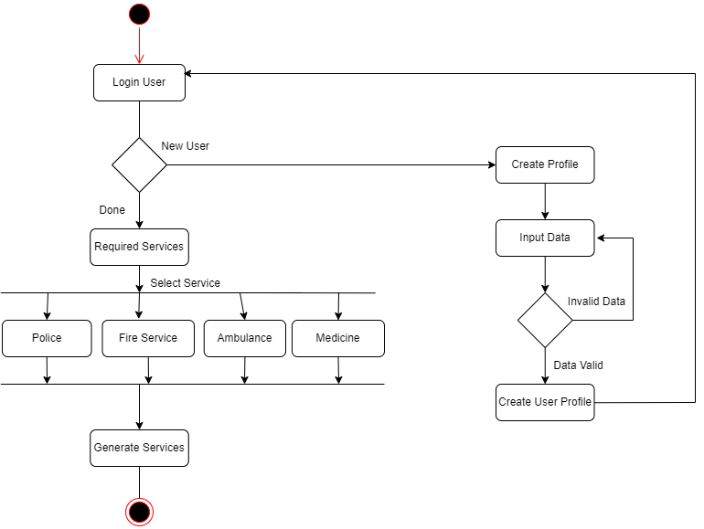

## Product Functions

**Major Functions of the product:**

**User:**

1. Sign-up
2. Login
3. Service List
4. Hire Ambulance
5. Order Medicine
6. Request for Fire Service
7. Request for Crime Related Service
8. Payment
9. Service Live Update
10. Service History
11. Logout

**Control Room:**

1. Sign-up
2. Login
3. Pending Service Requests
4. Forwarded Service Requests
5. Service Status
6. Service History
7. Logout

**Ambulance:**

1. Sign-up
2. Login
3. Request List
4. Service Status
5. History
6. Logout

**Fire Service:**

1. Sign-up
2. Login
3. Request List
4. Service Status
5. History
6. Logout

**Police:**

1. Sign-up
2. Login
3. Request List
4. Service Status
5. History
6. Logout

**Medicine Dispensary Shop:**

1. Sign-up
2. Login
3. Requested Medicine List
4. Service Status
5. History
6. Logout

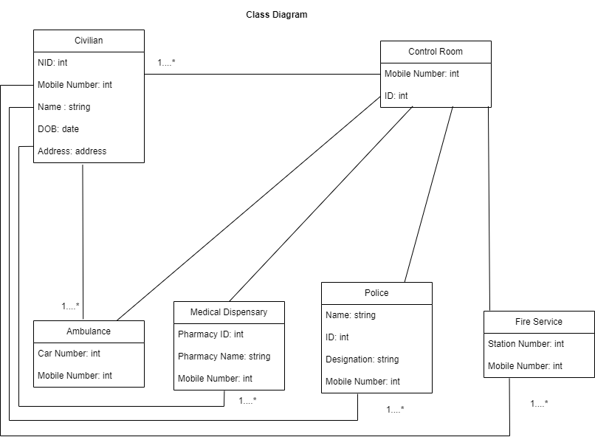

## User Classes and Characteristics

**Civilian:**

Anyone who faces the relevant problems can request for a service using this software.

Needed technical expertise: No need of technical expertise. Basic ideas about electronic devices are enough.

Security: One user can use only password for security or two factor authentication using mobile number or email address.

Privilege Levels: Civilian can only see their own profile and request details.

Experience: No previous experience is needed.

**Control Room:**

Anyone who is on duty in the police control room with valid user id and password can access this software.

Needed technical expertise: Specific training is needed for how to manage the civilian’s request and give immediate feedback. Intermediate idea about computer is necessary.

Security: This type of user must have valid user id and password provided by the authority. Also, they have to scan their id card to a scanner to login after giving user id and password [3].

Privilege Levels: Control room can see the civilian’s request and location. Then they just can forward it to the relevant department.

Experience: Finishing a training period is mandatory.

**Fire service:**

Anyone who is on duty in the fire service with valid user id and password can access this software.

Needed technical expertise: Specific training is needed for how to response to control room’s forwarded request. Intermediate idea about computer is necessary.

Security: This type of user must have valid user id and password provided by the authority. Also, they have to scan their id card to a scanner to login after giving user id and password [3].

Privilege Levels: Fire service can see the civilian’s request and location.

Experience: Finishing a training period is mandatory.

**Ambulance:**

Anyone who is on duty in the Ambulance service with valid user id and password can access this software.

Needed technical expertise: Knowing how to use a mobile phone is enough.

Security: This type of user must have valid user id and password provided by the authority. Also, they have to scan their id card to a scanner to login after giving user id and password [3].

Privilege Levels: Ambulance service can see the civilian’s request and location.

Experience: Finishing a training period is mandatory.

**Police:**

Anyone who is on duty in the police station with valid user id and password can access this software.

Needed technical expertise: Knowing how to use a mobile phone is enough.

Security: This type of user must have valid user id and password provided by the authority. Also, they have to scan their id card to a scanner to login after giving user id and password [3].

Privilege Levels: Police can see the civilian’s request and location.

Experience: Finishing a training period is mandatory.

**Medical dispensary shop:**

Anyone who is on duty in pharmacy with valid user id and password can access this software.

Needed technical expertise: Knowing how to use a computer is enough.

Security: This type of user must have valid user id and password provided by the authority. Also, they have to scan their id card to a scanner to login after giving user id and password [3].

Privilege Levels: They can see the civilian’s request and location.

Experience: Finishing a training period is mandatory

## Operating Environment

It will operate on any smartphone with android or IOS or Tizen or Windows, PC with Windows or Linux or Mac or other OS by using our application or any browser. Every device with latest or recent OS can run our application.

## Design and Implementation Constraints

**Hardware Limitations:** As our software is for every device including mobile phones, for this our software needs to be lite. Because of this some options are limited for the developers.

**Interfaces to other applications:** The software needs to interface with other mobile banking application. This can limit the options available to developers, as they will need to use technologies that are compatible with the other applications.

**Security considerations:** The software need to meet certain security requirements. This can limit the options available to developers, as they will need to use technologies that support the required security features.

**Corporate or regulatory policies:** A company's corporate policies or government regulations may restrict the use of certain technologies, tools, or languages. For example, a company may have a policy of only using open-source software, or a government may have regulations that require certain security features to be implemented.

**Specific technologies, tools, and databases to be used:** The company may have specific technologies, tools, and databases that they want to use. This can limit the options available to developers, as they will need to use the technologies that the company has specified.

**Design conventions or programming standards:** The company may prefer to utilize particular design conventions or programming standards. As a result, developers' options may be limited since they must adhere to the company's requirements.

## User Documentation

This software is designed in a way that every user can interpret the functionality by seeing the icons. Also, every user type can watch different video tutorial about how to use the software on the homepage before login. These videos are divided into some parts and arranges sequentially. Each functionality is described clearly, so everyone will understand the uses completely after watching the videos.

We will also provide different user manuals for each type of user.

# System Requirements

## Functional Requirements (System Features)

**1. Software Sign-up:**

* 1. Users shall be able to register to the software by using NID / passport/ birth certificate, mobile number, name, DOB, current address and email address.
  2. The sign-up information shall be stored in the database.

1.3 Users shall be able to create unique usernames and passwords during sign-up which shall be stored in the database.

1.4 The System shall be able to check if the username is already taken or not. If yes then user shall try another username.

1.5 If the sign-up is successful, the login page will be displayed.

**Priority Level:** High

**Precondition:** user have valid NID/passport/birth certificate and email/phone number.

**Cross-references:** None.

**2. Software Login**

2.1 The software shall allow users to login with their given username and password.

2.2 The software shall allow users to set a two-factor authentication using mobile number or email address.

2.3 The login credentials will be verified with database records.

2.4 If the login successful, the home page of the user account will be displayed.

2.5 If the number of login attempt exceed its limit (3 times), the system shall block the user account login until verified by mobile number or email address.

**Priority Level:** High **Precondition:** user have valid user id and password  
**Cross-references:** None

**3. Service List**

3.1 The software shall show the service list after login.

3.2 The user shall request for a service to the control room.

3.3 The software shall show the requested service page.

**Priority Level:** Medium **Precondition:** user should be logged in the system.  
**Cross-references:** None

**4.Hire Ambulance**

4.1 The user shall request for an ambulance to the control room.

4.2 The user shall choose the type of an ambulance.

4.3 The user shall describe her/his situation.

**Priority Level:** High **Precondition:** user should be logged in the system and location should be on and enough balance to pay.  
**Cross-references:** None

**5. Fire Service.**

5.1 The user shall request for fire service to the control room.

5.2 The user shall describe her/his situation.

**Priority Level:** High **Precondition:** user should be logged in the system and location should be on.  
**Cross-references:** None

**6. Police Service**

6.1 The user shall request for police service to the control room.

6.2 The user shall describe her/his situation.

**Priority Level:** High **Precondition:** user should be logged in the system and location should be on.  
**Cross-references:** None

1. **Medicine Dispensary**

7.1 The user shall request for medicines to the control room.

7.2 The user shall write the medicine names and quantities.

**Priority Level:** High **Precondition:** user should be logged in the system and location should be on and enough balance to pay.  
**Cross-references:** None

**Priority Level:** High **Precondition:** user should be logged in the system and location should be on.  
**Cross-references:** None

**8. History:**

8.1 The user shall see his previous report details and can give feedback or suggestion.

**Priority Level:** Low **Precondition:** user should be logged in the system.  
**Cross-references:** None

**9. Notifications:**

9.1 The user shall be notified if there any update related his report.

**Priority Level:** Low **Precondition:** user should be logged in the system.  
**Cross-references:** None

**10. Payment:**

10.1 The user shall pay by using any bank account or any mobile banking system for medicines and private ambulance services.

**Priority Level:** High **Precondition:** user should be logged in the system.  
**Cross-references:** None

**11. Profile:**

11.1 The user shall see his personal details.

11.2 The user shall update his personal details.

**Priority Level:** Medium **Precondition:** user should be logged in the system.  
**Cross-references:** None

**12. Forgot Password:**

12.1 The user shall set a new password verifying by mobile number or email address.

**Priority Level:** Medium **Precondition:** user should be logged in the system.  
**Cross-references:** None

1. **Logout**

13.1 The software shall allow the users to logout of the system.

**Priority Level:** Medium

**Precondition:** user should be logged in the system.  
**Cross-references:** None

## Non-Functional/Quality Requirements

Nonfunctional requirements specify the quality attributes of a system and how well it should perform. Here are some nonfunctional requirements for the web-based system for emergency services:

**1. Performance:** The system is able to handle a large number of concurrent users without any performance degradation, ensuring fast response times and minimal delays in emergency service delivery.

**Priority Level:** High **Precondition:** N/A  
**Cross-references:** none

**2. Security:** The system is complied with strict security standards, including data encryption and authentication mechanisms, to protect sensitive user data from unauthorized access or cyber-attacks.

**Priority Level:** High **Precondition:** N/A  
**Cross-references:** none

**3. Availability:** The system is available 24/7, ensuring that users can access emergency services at any time of the day or night.

**Priority Level:** High **Precondition:** N/A  
**Cross-references:** none

**4. Reliability:** The system is reliable, ensuring that emergency services are always available, and the system does not crash or experience downtime that could delay the delivery of emergency services.

**Priority Level:** Medium **Precondition:** N/A  
**Cross-references:** none

**5. Usability:** The system is user-friendly, with a simple and intuitive interface that is easy to navigate, even for non-technical users. This ensures that users can quickly and efficiently access emergency services without any confusion.

**Priority Level:** Medium **Precondition:** N/A  
**Cross-references:** none

**6. Location:** The system uses Google’s API to get exact and accurate location of the user.

**Priority Level:** High **Precondition:** User’s device location permission should be on.  
**Cross-references:** none

**7. Scalability:** The system is scalable, allowing for easy expansion to accommodate an increasing number of users, emergency service providers, and service requests.

**Priority Level:** Medium **Precondition:** N/A  
**Cross-references:** none

**8. Maintainability:** The system is easy to maintain, with a robust support system that ensures fast resolution of any issues or bugs that may arise.

**Priority Level:** Medium **Precondition:** N/A  
**Cross-references:** none

**9. Accessibility:** The system must be accessible to all users, including those with disabilities, by complying with accessibility standards and guidelines.

**Priority Level:** Medium **Precondition:** N/A  
**Cross-references:** none

**10. Interoperability:** The system should be able to communicate with other emergency service providers, such as hospitals, police, and fire departments, to ensure efficient and effective emergency response.

**Priority Level:** High **Precondition:** N/A  
**Cross-references:** none

**11. Compatibility:** The system must be compatible with a range of devices, including desktops, laptops, tablets, and smartphones, to ensure that users can access emergency services from any device.

**Priority Level:** Medium **Precondition:** N/A  
**Cross-references:** none

**12. Auditability:** The system should maintain a detailed audit trail of all emergency service requests and responses, including timestamps, user identities, and service provider details, to enable forensic investigations and quality assurance.

**Priority Level:** Medium **Precondition:** N/A  
**Cross-references:** none

**13. Legal compliance:** The system must comply with all relevant laws, regulations, and policies related to emergency services, data protection, privacy, and cybersecurity.

**Priority Level:** Medium **Precondition:** N/A  
**Cross-references:** none

By incorporating these nonfunctional requirements into the design and development of the web-based system, it will ensure that the system delivers emergency services efficiently, effectively, and securely, ultimately improving the overall response time and potentially saving lives.

## Project Requirements

**Tools:**

* The development team needs computers which supports IntelliJ IDEA to code in java language in week 2.
* The system needs enough data storage capacity in the database to keep all the user’s information.
* The system needs backup processes to manage data corruption, or a human-caused event, such as a malicious attack (virus or malware), or accidental deletion of data.
* The system developer needs selenium tools in perform testing activities in week 6.

# Design and Interface Requirements

## UML Diagrams

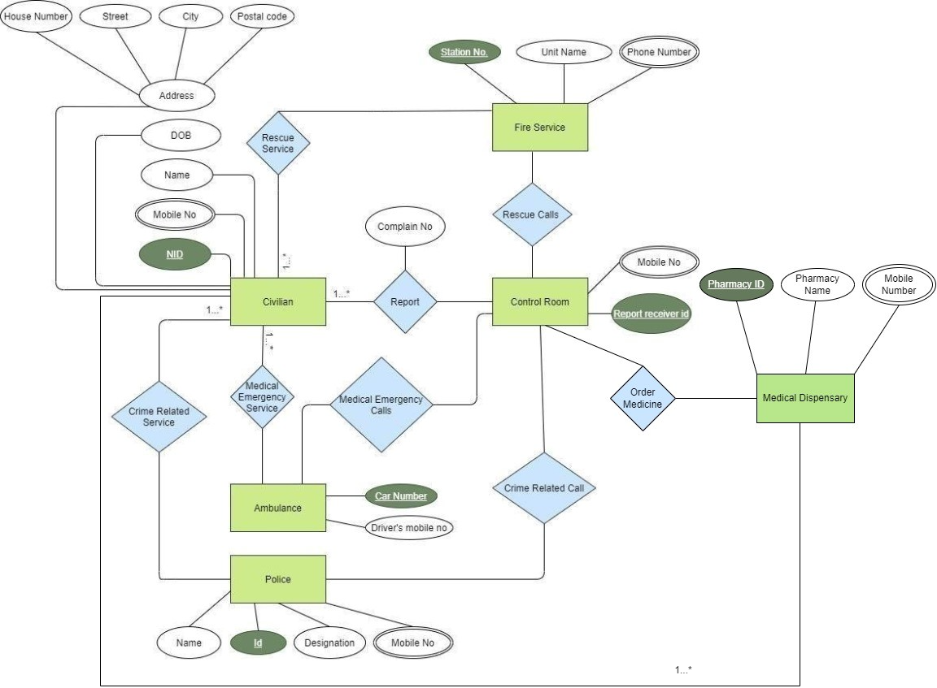*Fig: ER Diagram*

## Data Dictionary

|  |  |  |  |  |
| --- | --- | --- | --- | --- |
| **Entity** | **Attribute** | **Type/Size** | **Validation** | **Key** |
| Civilian | NID | Number (10) | 1000000000-9999999999 | Primary |
| Civilian | Mobile Number | Number (11) | Required |  |
| Civilian | Name | Text (20) | Required |  |
| Civilian | DOB | Date (8) | Valid Date |  |
| Civilian | Address | Text (35) | Required |  |
| Fire Service | Station No | Number (10) | 1000000000-9999999999 | Primary |
| Fire Service | Unit Name | Text (15) | Required |  |
| Fire Service | Phone Number | Number (11) | Required |  |
| Control Room | Report Receiver ID | Number (10) | 0000000001-9999999999 | Primary |
| Control Room | Mobile Number | Number (11) | Required |  |
| Ambulance | Car Number | Text (10) | Required | Primary |
| Ambulance | Driver’s Mobile Number | Number (11) | Required |  |
| Police | ID | Number (10) | 0000000001-9999999999 |  |
| Police | Name | Text (20) | Required |  |
| Police | Designation | Text (15) | Required |  |
| Police | Mobile Number | Number (11) | Required |  |
| Medical Dispensary | Pharmacy ID | Number (10) | 0000000001-9999999999 | Primary |
| Medical Dispensary | Pharmacy Name | Text (15) | Required |  |
| Medical Dispensary | Mobile Number | Number (11) | Required |  |

## UI/UX Design Specification

**Login**

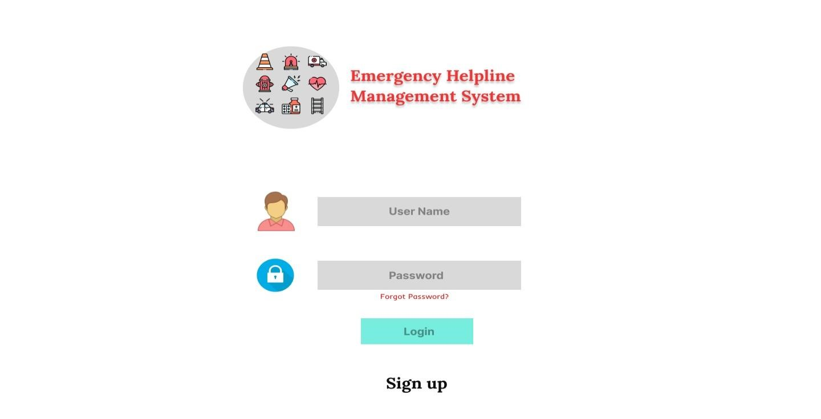

**Sign-up**

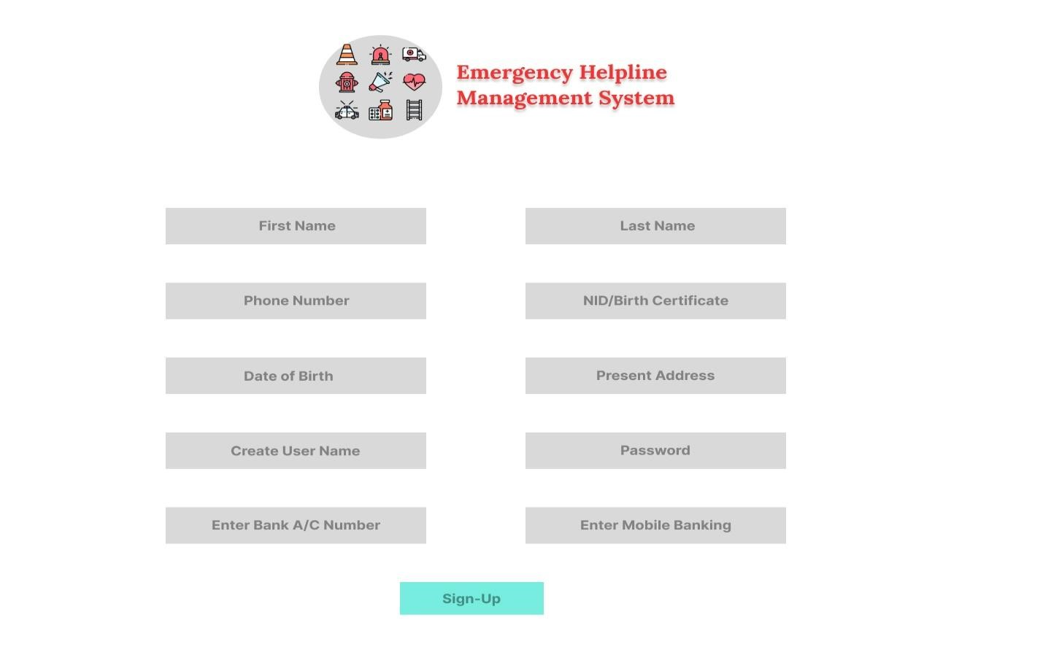

**Service List**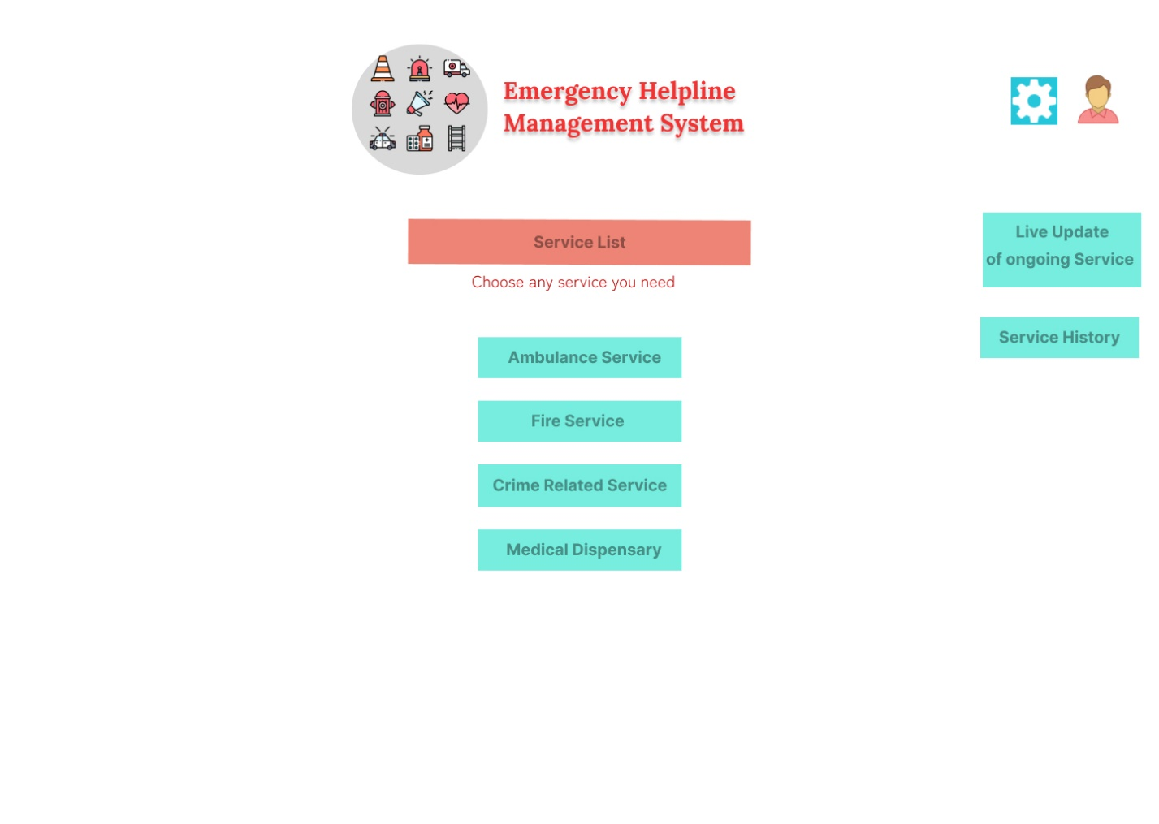

**Crime Related Service**

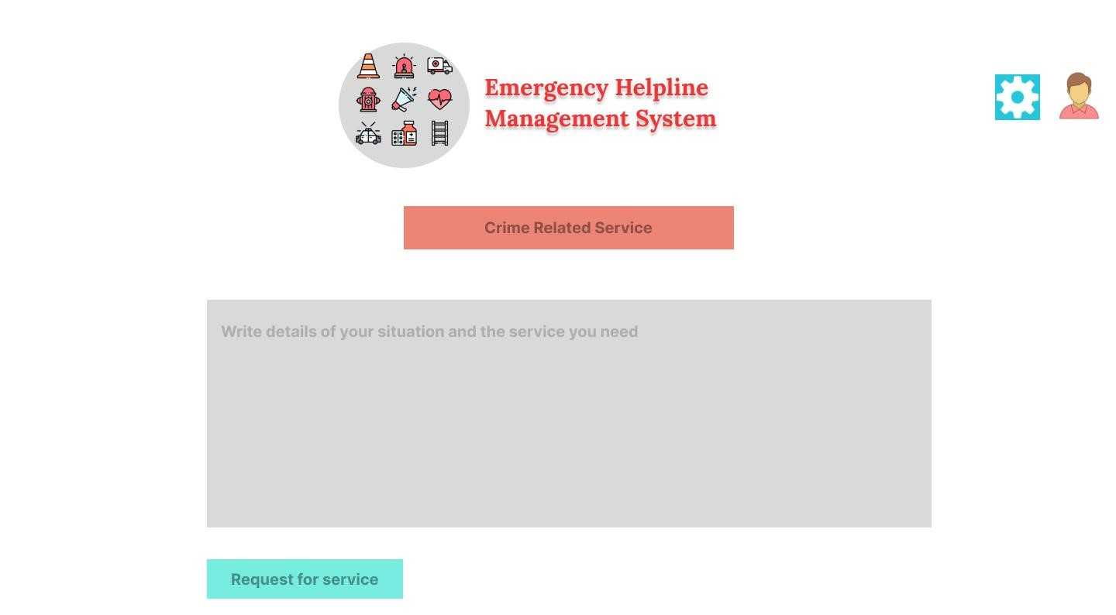

**Medical Services**

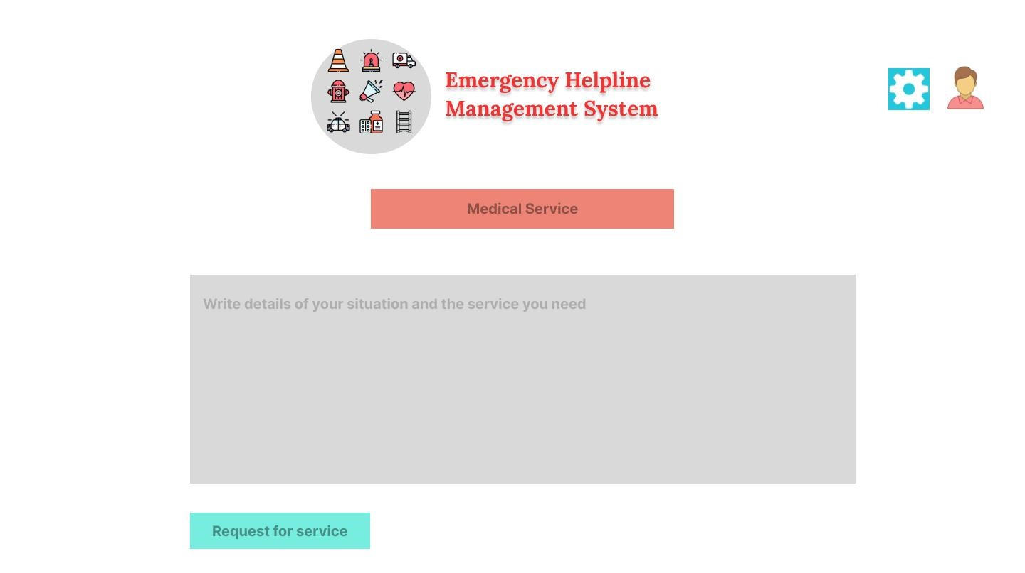

**Fire Service**

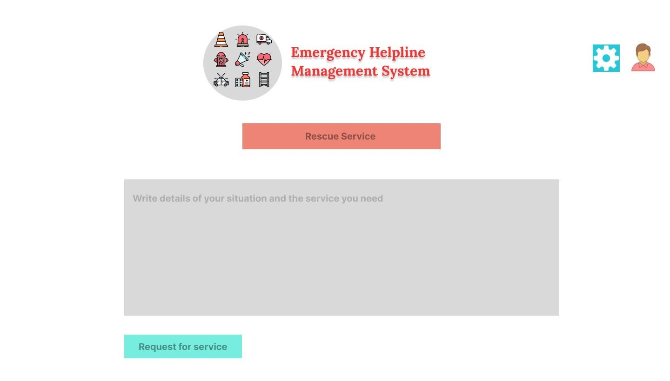

**Edit Profile**

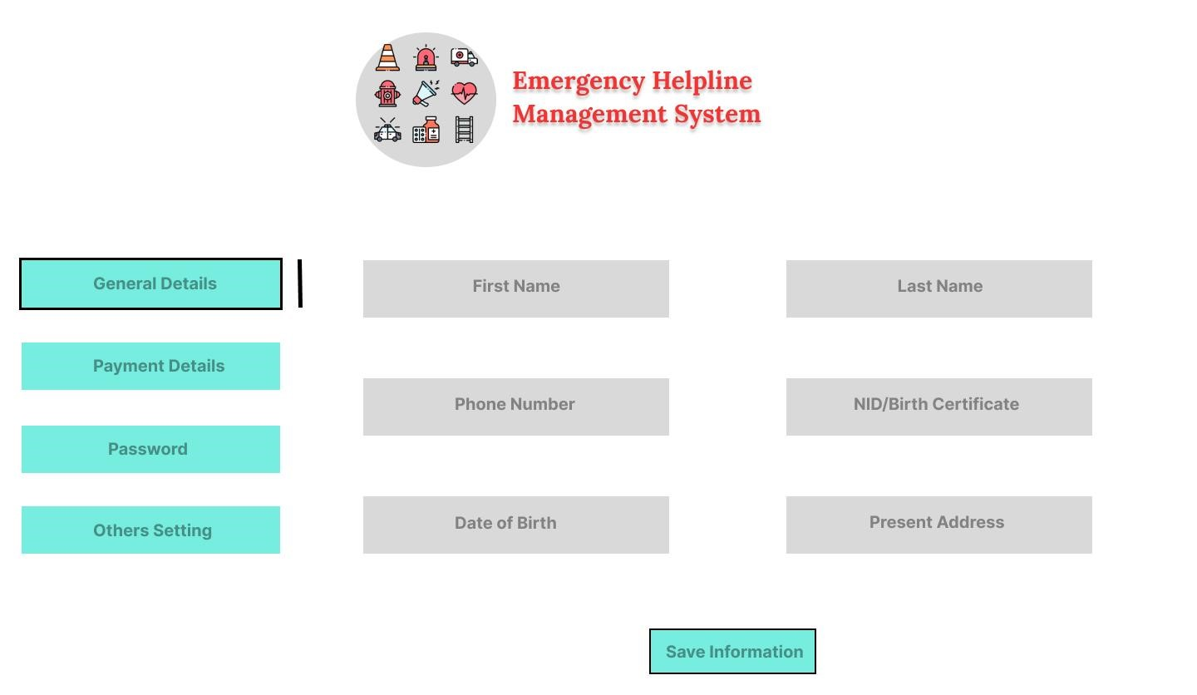

**Forgot Password**

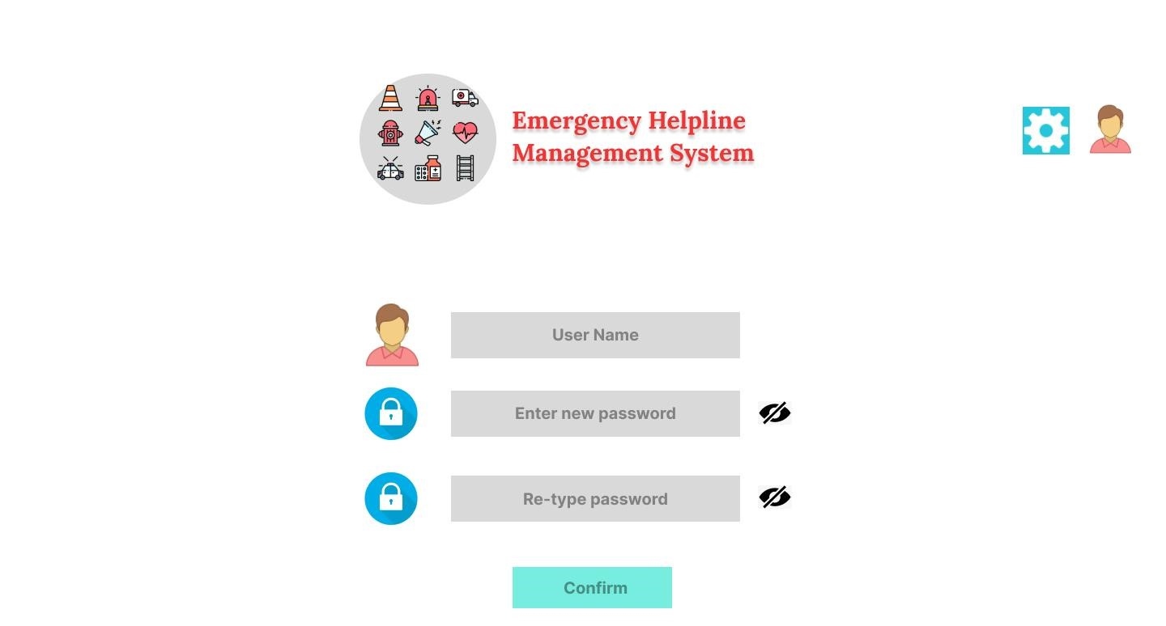

**Feedback**

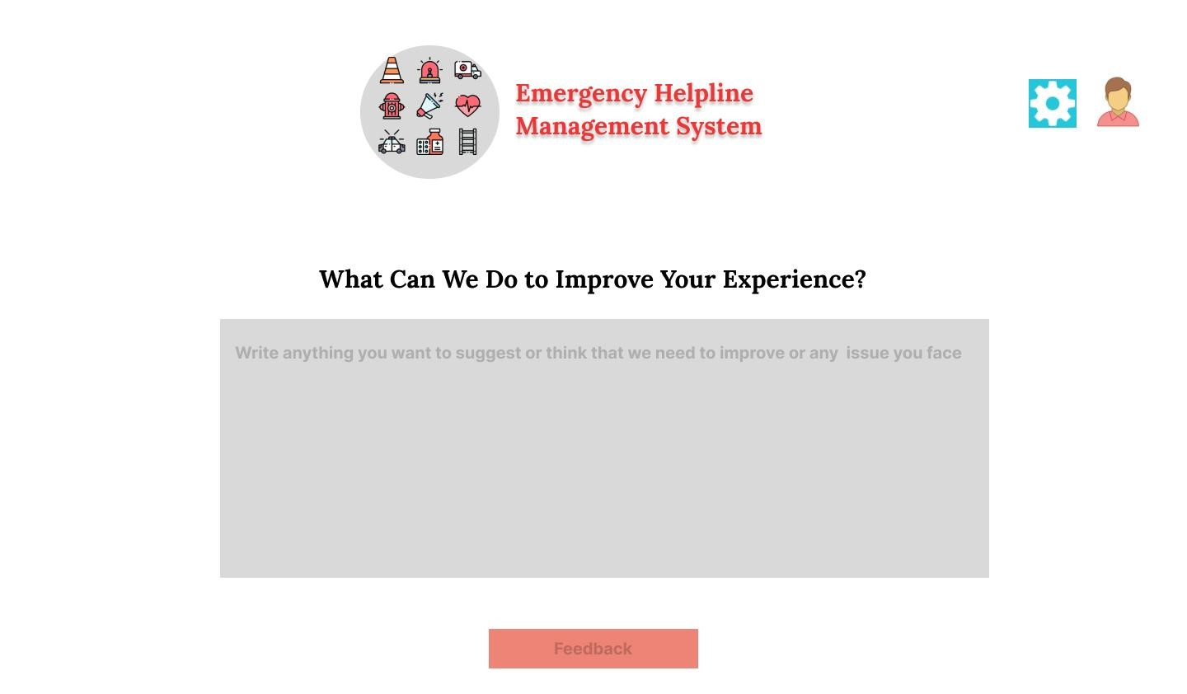

**Payment**

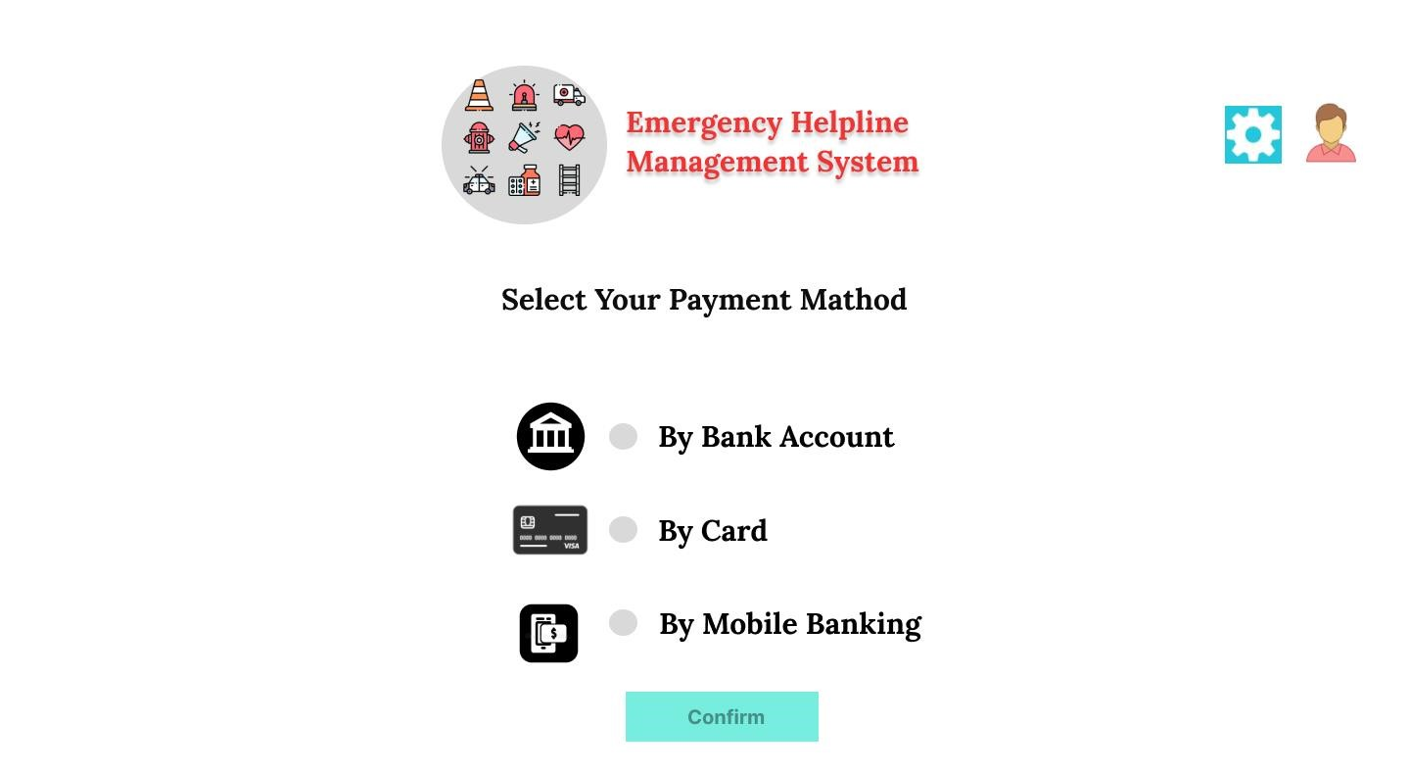

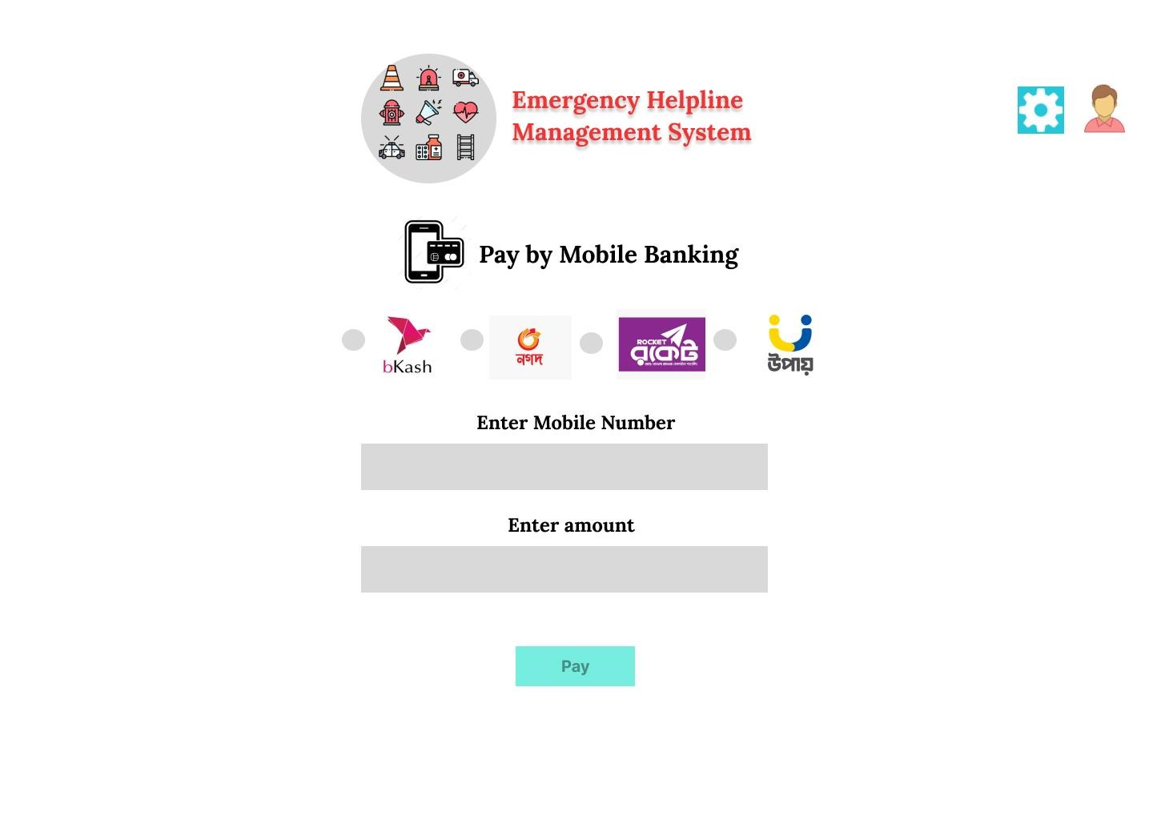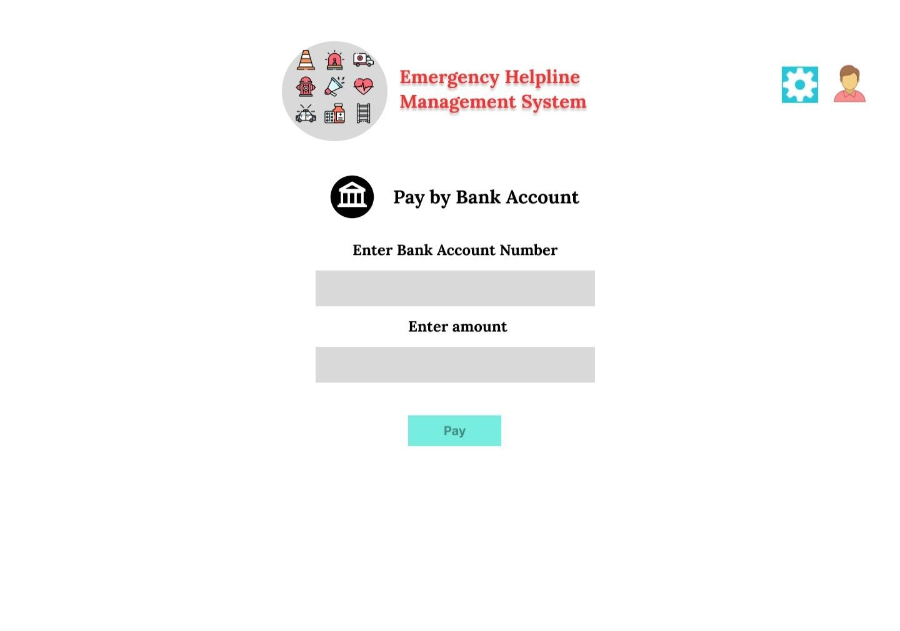

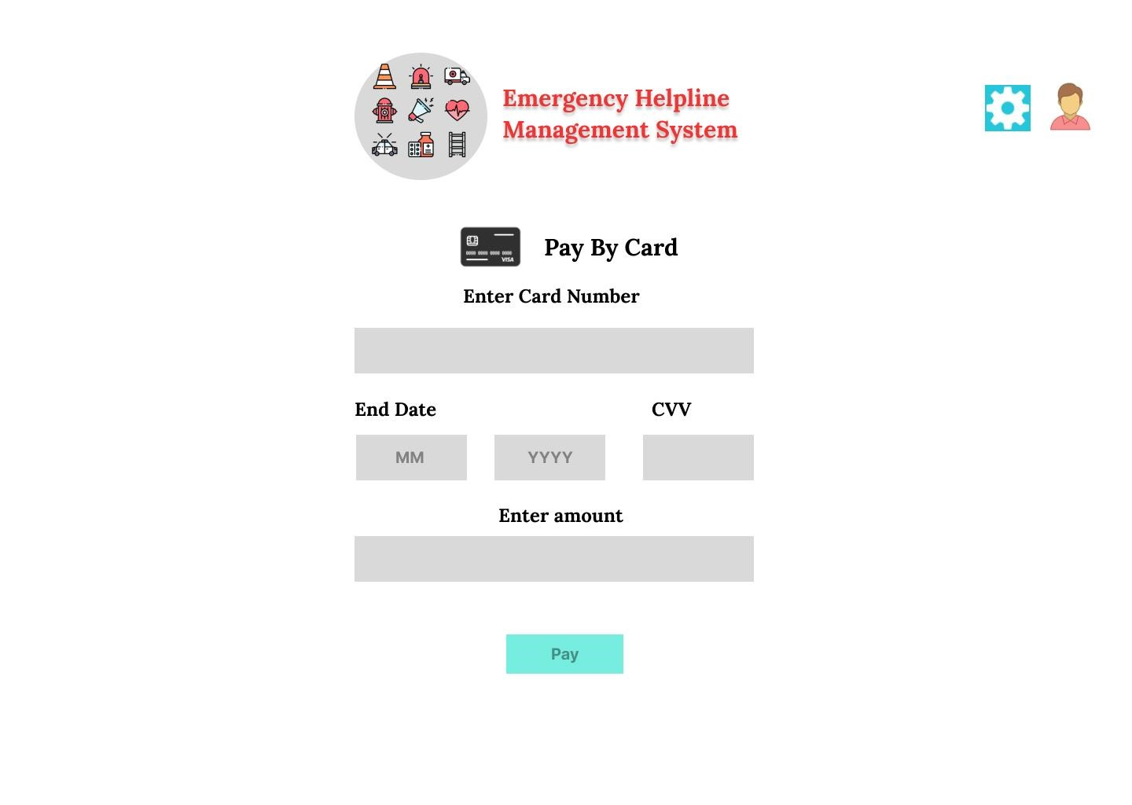

**Service History (Control Room)**

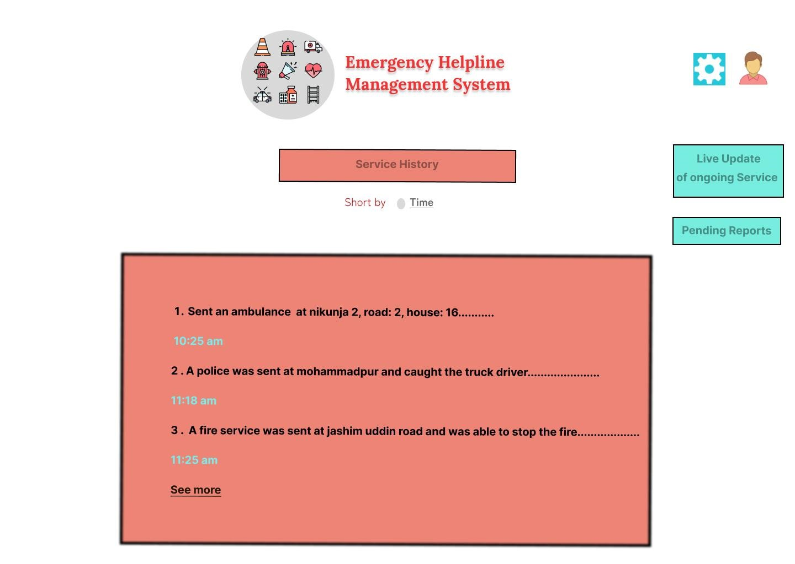

**Pending Reports (Control Room)**

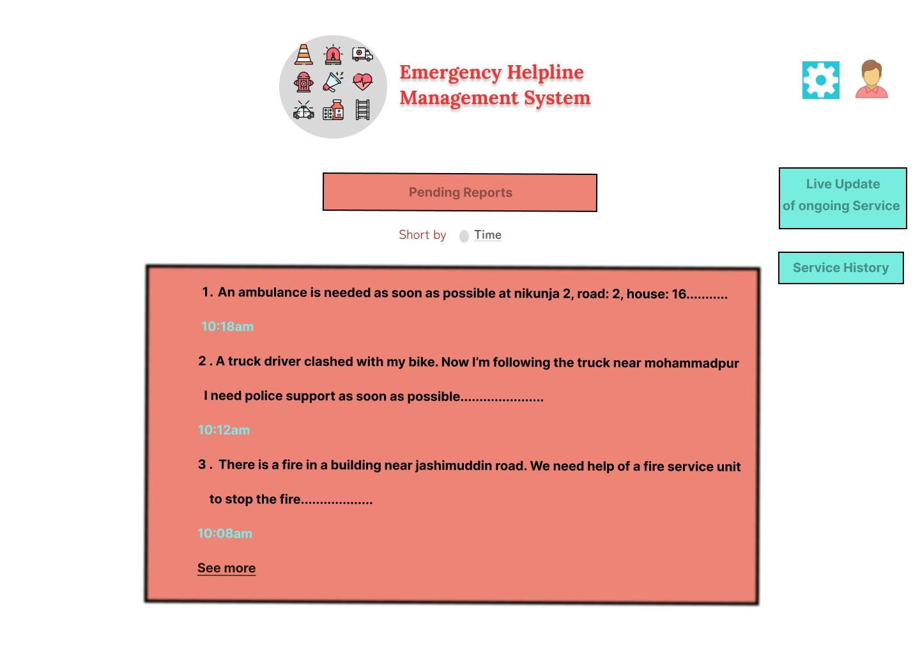

# Conclusion

The emergency helpline management system is a critical component of any community's emergency response infrastructure. By providing a single point of contact for civilians to request emergency services through smart devices by reporting or requesting using text, the system helps to ensure that help is dispatched quickly and efficiently.

The system works by having civilians write to a single control room to report an emergency. The report is then checked by the control room, where trained operators assess the situation and forward the appropriate request to the responsible entity and give immediate feedback to the user. In some cases, the control room may also provide assistance to the civilian, such as by providing first aid instructions or calming them down.

The emergency services that are dispatched by the control room vary depending on the nature of the emergency. For example, a fire department may be dispatched for a fire, a police department may be dispatched for a crime, and an ambulance may be dispatched for a medical emergency.

In some cases, the emergency services that are dispatched may be free of charge, while in other cases, they may be paid for by the civilian. The cost of the services will vary depending on the jurisdiction and the type of service that is provided.

The emergency helpline management system is an essential tool for ensuring the safety of communities. By providing a single point of contact for civilians to request emergency services, the system helps to ensure that help is dispatched quickly and efficiently.

Here are some additional benefits of the emergency helpline management system:

* It can help to reduce the number of deaths and injuries from emergencies.
* It can help to reduce the amount of property damage caused by emergencies.
* It can help to reduce the amount of stress and anxiety experienced by civilians during emergencies.
* It can improve the public's perception of the government's ability to respond to emergencies.

The emergency helpline management system is a useful software that can help to keep communities safe. By understanding how the system works and using it appropriately, civilians can help ensure that they receive the help they need in an emergency.